Tables and figures in the article

**Table 1: The primers used for polymerase chain reaction**

|  |  |  |  |
| --- | --- | --- | --- |
|  |  | Primer sequence |  |
| First round primers |  | Upstream primers | 5′-TGAGATGTAGCAATGTAAACAGCTA-3′ |
|  |  | Downstream primers | 5′-CCACTGCCCTAAGAGGTCCA-3′ |
| Second round of primers |  | Upstream primers | 5′-TGTAAACAGCTACTTTTTATATGATC-3′ |
|  |  | Downstream primers | 5′-GGTAAGGAGCCTAGAGGACAGA -3′ |

**Table 2: Baseline clinical characteristics of the AF group and the healthy group**.

|  |  |  |  |  |  |
| --- | --- | --- | --- | --- | --- |
| Parameters |  |  | Atrial fibrillation group (n=98). | Control group (n=88). | P-value |
| Gender (M/F） |  |  | 58/40 | 41/47 | 0.086 |
| Age(years) |  |  | 73.54±9.04 | 63.24±10.18 | ＜0.001 |
| BMI,kg/m2 |  |  | 23.20±3.34 | 23.70±3.38 | 0.316 |
| Paroxysmal atrial fibrillation |  |  | 30/68 |  |  |
| History of smoking |  |  | 23/75 | 6/82 | 0.002 |
| Hypertension |  |  | 73/25 | 44/44 | 0.001 |
| Diabetes mellitus |  |  | 25/73 | 19/69 | 0.530 |
| Coronary heart disease |  |  | 61/37 | 16/72 | ＜0.001 |
| Stroke/TIA |  |  | 45/53 | 11/77 | ＜0.001 |
| Dyslipidemia |  |  | 18/80 | 11/77 | 0.271 |

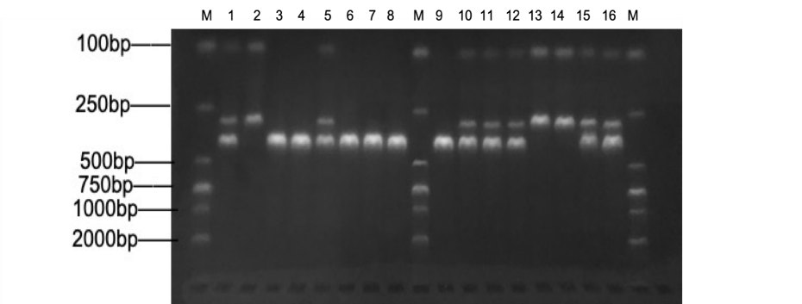

**Figure 1 : Gel electrophoresis of the restriction of poly­merase chain reaction product. Amplified DNA fragments of the PITX2 gene patients with atrial fibrillation digested with restriction enzyme MboI and produced bands are shown in table 3**

M：Marker；1、5、10、11、12、15、16：TCgenotype；2、13、14：CCgenotype；3、4、6、7、8、

9：TTgenotype

**Table 3: Fragment lengths after digestion with different genotypes**

|  |  |  |  |  |  |
| --- | --- | --- | --- | --- | --- |
| genotype |  |  |  | number of recognition sites | Fragment length after digestion |
| TT type |  |  |  | 0 | 413bp |
| TC type |  |  |  | 2 | 413bp、293bp、120bp |
| CC type |  |  |  | 1 | 293bp、120bp |

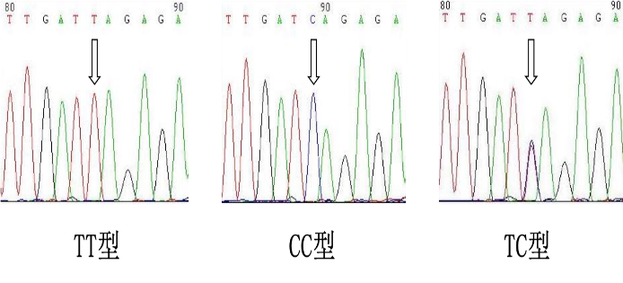

**Figure 2: rs 2200733 site gene sequencing diagram**

**Table 4: Genotype frequency and allele frequency distribution of two groups**

|  |  |  |  |  |  |  |  |
| --- | --- | --- | --- | --- | --- | --- | --- |
| group | Number of cases | Genotype frequency n (%) | | | Allele frequency n (%) | | HWE-P |
|  |  | TT | TC | CC | T | C |  |
| Atrial fibrillation group | 98 | 44（44.90） | 49（50.00） | 5（5.10） | 137（69.90） | 59（30.10） | 0.176 |
| Control group | 88 | 26（29.55） | 47（53.41） | 15（17.05） | 99（56.25） | 77（43.75） | 0.727 |
| 2 |  | 4.656 | 0.216 | 6.892 | 7.447 | |  |
| P |  | 0.031 | 0.642 | 0.009 | 0.006 | |  |
| OR |  | 1.943 | 0.872 | 0.262 | 1.806 | |  |
| 95%CI |  | 1.059～3.564 | 0.490～1.552 | 0.091～0.753 | 1.179～2.766 | |  |

**Table 5: SNP rs 2200733 logistic regression analysis of gene polymorphisms and susceptibility to atrial**

|  |  |  |  |  |  |  |  |  |  |
| --- | --- | --- | --- | --- | --- | --- | --- | --- | --- |
| rs2200733 | | allele |  | Atrial fibrillation group | Control group | ORvalue（95%CI） | Pvalue | AOR*value（95%CI） | P*value |
| genotype | | CC |  | 5 | 15 | 1 |  |  |  |
|  | | TC |  | 49 | 47 | 3.128（1.053～9.287） | 0.040 | 2.207（0.558~8.723） | 0.259 |
|  | | TT |  | 44 | 26 | 5.077（1.653～15.595） | 0.005 | 4.557（1.129~18.396） | 0.033 |
| Stealth model | | TT |  | 44 | 26 | 1 |  |  |  |
|  | | TC+CC |  | 54 | 62 | 0.515（0.281~0.944） | 0.032 | 0.425（0.201~0.900） | 0.025 |
| Dominant model | | CC |  | 5 | 15 | 1 |  |  |  |
|  | | TT+TC |  | 93 | 73 | 3.822（1.327~11.004） | 0.013 | 3.072（0.819~11.527） | 0.096 |
| Additive model | | TC |  | 49 | 47 | 1 |  |  |  |
|  | | TT+CC |  | 49 | 41 | 1.146（0.644~2.040） | 0.642 | 1.546（0.749~3.194） | 0.239 |
|  | Note: The AOR* value and P* value were adjusted for age, sex, history of hypertension, history of coronary heart disease, and history of smoking, respectively, after adjusting the OR value and P value. | | | | | | | | |

**supported data**

**Reaction system and reaction conditions：** See the table for details s1、s2、s3、s4

S. Table 1: First round of PCR reaction system

|  |  |  |
| --- | --- | --- |
| Reagent name |  | volume（μl） |
| 2×Taq PCR MasterMix |  | 25 |
| Forward primers（Forward） |  | 2 |
| Reverse primers（Rerverse） |  | 2 |
| DNAtemplate |  | 3 |
| ddH2O |  | 18 |
| General system |  | 50 |

S. Table 2 : Conditions for the first round of PCR reactions

|  |  |  |  |
| --- | --- | --- | --- |
| temperature（°C） |  | Time | The number of cycles |
| Prevariance：95 |  | 5 min | 1 |
| denaturation：95 |  | 30 s | 40 |
| anneal：62 |  | 30 s |
| extend：72 |  | 45 s |
| extend：72 |  | 6 min | 1 |

Dilute the first round of PCR products 10-fold as a DNA template for the second round of PCR reactions. The second round of PCR reactions is carried out according to the reaction system and conditions in the following table

S. Table 3: Second round of PCR reaction system

|  |  |  |
| --- | --- | --- |
| Reagent name |  | volume（μl） |
| 2×Taq PCR MasterMix |  | 25 |
| Forward primers（Forward） |  | 2 |
| Reverse primers（Rerverse） |  | 2 |
| DNA template |  | 3 |
| ddH2O |  | 18 |
| General system |  | 50 |

S. Table 4: Second Round PCR Reaction Conditions

|  |  |  |  |
| --- | --- | --- | --- |
| temperature（°C） | Time |  | The number of cycles |
| Prevariance：95 | 5 min |  | 1 |
| denaturation：95 | 25 s |  | 35 |
| anneal：60 | 25 s |  |
| extend：72 | 35 s |  |
| extend：72 | 1. min |  | 1 |

The second round of PCR products is digested according to s. Table 4: note that the restriction enzyme should be placed on ice immediately after removal from the -20 °C freezer and added at the last step, replacing the tip of the gun with each addition

S. Table 5: Digestion reaction system

|  |  |  |
| --- | --- | --- |
| Reagent name |  | volume（μl） |
| PCRproduct |  | 10 |
| 10*buffer |  | 2 |
| Restriction enzyme MboI |  | 1 |
| ddH2O |  | 7 |
| General system |  | 20 |

After the reaction solution was well mixed, it was placed in a 37 °C water bath pot overnight (about 14 hours). In order to make the reaction liquid mix well, you can use the gun to repeatedly suck the mix or use your fingers to flick the wall of the tube, and then quickly centrifuge, paying attention to non-oscillation.

S. **Agarose gel electrophoresis**

Preparation of related solutions and preparation of agarose gels

Electrophoresis buffer (TAE) configuration: Tris 242g + Na2EDTA2H2O- 37.2g + deionized water 600 mL, stirred well to dissolve, add again 57.1 mL acetic acid, stir well and finally add deionized water to adjust the solution to 1 L to obtain 50* TAE buffer and store at room temperature.

3% Agarose gel electrophoresis configuration: 3 g agarose + 100 ml 1* TAE electrophoresis buffer (dilute the 50* TAE buffer obtained in the previous step 50x to obtain 1* TAE buffer), microwave over medium for 1min to boil, melt and cool the agar to 60 °C, mix well with EB dye (2-5ul) left and right, slowly pour the warm gel into the adhesive film of the comb, when there are bubbles sucked off with the tip, the thickness of the gel is generally 3-5mm, and then placed at room temperature for 30-60min, the gel is visible to solidify completely.

Glue into the electrophoresis tank, pull out the comb, add 1* TAE electrophoresis buffer, soak the gel. Add 10 μl of the digestion product to each well, adding Marker on both sides and in the middle. The parameters of the electrophoresis instrument are adjusted to Time mode, the voltage is 100V, the current is 100mA, and the time is 40min.

**S. DNA Preparation**

The blood genomic DNA extraction kit (0.1-1ml) (DP318) of Tiangen Biochemical Technology (Beijing) Co., Ltd. was used to extract DNA from blood samples according to the instructions, and the concentration and purity were detected with a spectrophotometer. The sample was taken out of the -80°C refrigerator and dissolve it at room temperature. Blood sample was taken 200μl of blood sample into a 1.5ml EP tube, add 1L of erythrocyte lysate, invert and mix well, put it in a centrifuge, centrifuge at 10,000 rpm for 1 min, and see if the nuclei are precipitated. Add 200 μl of buffer GS to the nuclear pellet collected by centrifugation and shake until it is thoroughly mixed. 20 μl proteinase K solution was added with the 200 μl of buffer GB, fully invert and mix, put it into a 56°C incubator for 10 min, and invert and mix 3 times. 200 μl of absolute ethanol was added, inverted and was mixed well, flocculent precipitation may appear at this time. The adsorption column was added into the collection tube, add the solution and flocculent precipitate obtained in the previous step into the adsorption column, centrifuge at 12000 rpm for 30 sec, and remove the column liquid. 500 μl of buffer GD was added to the adsorption column, centrifuge at 12000 rpm for 30 sec, and remove the column liquid. 600 μl was added to rinse solution PW to the adsorption column, centrifuge at 12,000 rpm for 30 sec, and remove the column solution, this step was again repeated. Centrifuge at 12,000 rpm for 2 min, waste solution was discarded, and placed at room temperature for 10 minutes to completely dry the residual rinsing solution in the adsorption material, so as to prevent the residual ethanol in the rinsing solution from affecting subsequent PCR and enzyme digestion reactions. The adsorption column was transferred to a 1.5 ml EP tube, 100 μl was added to the elution buffer TB dropwise to the middle of the adsorption membrane, leave it at room temperature for 5 min, and centrifuge at 12,000 rpm for 2 min. The concentration and purity of the obtained DNA was detected under a UV spectrophotometer. After testing, the resulting DNA concentration was about 15-30 ng/μl. The ratio of OD260/OD280 is 1.7-1.9, and the purity is high. The obtained DNA was sub-packaged and stored in a -20°C refrigerator, waiting for a unified PCR reaction.